**Working with the Map**

*EPANET displays a map of the pipe network being modelled. This chapter describes how you can manipulate this map to enhance your visualization of the system being modelled*

## **Selecting a Map View:**

One uses the Map Page of the Browser to select a node and link parameter to view on the map. Parameters are viewed on the map by using colours, as specified in the Map Legends to display different ranges of values.

Node parameters available for viewing include:

* Elevation
* Base Demand (nominal or average demand)
* Initial Quality (water quality at time zero)
* *Actual Demand (total demand at current time)
* *Hydraulic Head (elevation plus pressure head)
* *Pressure
* *Water Quality

Link parameters available for viewing include:

* Length
* Diameter
* Roughness Coefficient
* Bulk Reaction Coefficient
* Wall Reaction Coefficient
* *Flow Rate
* *Velocity
* *Headloss (per 1000 feet (or meters) of pipe)
* *Friction Factor (as used in the Darcy-Weisbach headloss formula)
* *Reaction Rate (average over length of pipe)
* *Water Quality (average over length of pipe)

The items marked with asterisks are computed quantities whose values will only be available if a successful analysis has been run on the network

## **Setting the Map’s Dimensions:**

The physical dimensions of the map must be defined so that map coordinates can be properly scaled to the computer’s video display. To set the map’s dimensions:

1. Select **View >> Dimensions**.
2. Enter new dimension information into the Map Dimensions dialog that appears or click the **Auto-Size** button to have EPANET compute dimensions based on the coordinates of objects currently included in the network.
3. Click the **OK** button to re-size the map.

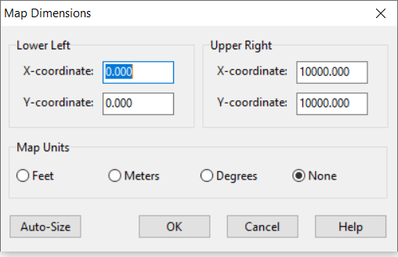

## **Utilizing a Backdrop Map:**

EPANET can display a backdrop map behind the pipe network map. The backdrop map might be a street map, utility map, topographic map, site development plan, or any other picture or drawing that might be useful. For example, using a street map would simplify the process of adding pipes to the network since one could essentially digitize the network’s nodes and links directly on top of it.

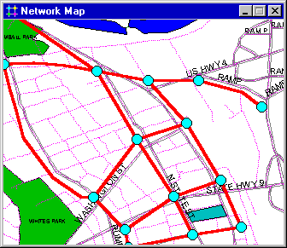

The backdrop map must be a Windows enhanced metafile or bitmap created outside of EPANET. Once imported, its features cannot be edited, although its scale and extent will change as the map window is zoomed and panned.

Selecting **View >> Backdrop** from the Menu Bar will display a sub-menu with the following commands:

* **Load** (loads a backdrop map file into the project)
* **Unload** (unloads the backdrop map from the project)
* **Align** (aligns the pipe network with the backdrop)
* **Show/Hide** (toggles the display of the backdrop on and off)

When first loaded, the backdrop image is placed with its upper left corner coinciding with that of the network’s bounding rectangle. The backdrop can be re-positioned relative to the network map by selecting **View >> Backdrop >> Align**. This allows an outline of the pipe network to be moved across the backdrop (by moving the mouse with the left button held down) until one decides that it lines up properly with the backdrop. The name of the backdrop file and its current alignment are saved along with the rest of a project’s data whenever the project is saved to file. For best results in using a backdrop map:

* Use a metafile, not a bitmap.
* Dimension the network map so that its bounding rectangle has the same aspect ratio (width-to-height ratio) as the backdrop.

## **Zooming the Map:**

To Zoom In on the map:

1. Select **View >> Zoom In** or click image102 on the Map Toolbar.
2. To zoom in 100%, move the mouse to the center of the zoom area and click the left button.

To Zoom Out on the map:

1. Select **View >> Zoom Out** or click image103 on the Map Toolbar.
2. Move the mouse to the center of the new zoom area and click the left button.

## **Panning the Map:**

1. Select **View >> Pan** or click image104 on the Map Toolbar.
2. With the left button held down over any point on the map, drag the mouse in the direction you wish to pan in.
3. Release the mouse button to complete the pan.

## **Finding an Object:**

1. Select **View >> Find** or click image105 on the Standard Toolbar**.**
2. In the Map Finder dialog box that appears, select **Node** or **Link** and enter an ID label.
3. Click **Find**.

 the node/link exists it will be highlighted on the map and in the Browser. If the map is currently zoomed in and the node/link falls outside the current map boundaries, the map will be panned so that the node/link comes into view. The Map Finder dialog will also list the ID labels of the links that connect to a found node or the nodes attached to a found link.

To find a listing of all nodes that serve as water quality sources:

1. Select **View >> Find** or click image106 on the Standard Toolbar**.**
2. In the Map Finder dialog box that appears, select **Sources**.
3. Click **Find**.

The ID labels of all water quality source nodes will be listed in the Map Finder. Clicking on any ID label will highlight that node on the map.

## **Map Legends:**

There are three types of map legends that can be displayed. The Node and Link Legends associate a colour with a range of values for the current parameter being viewed on the map. The Time Legend displays the clock time of the simulation time period being viewed. To display or hide any of these legends check or uncheck the legend from the **View >> Legends** menu. Double-clicking the mouse over it can also hide a visible legend.

To edit the Node Legend:

1. Either select **View >> Legends >> Modify >> Node** or right-click on the legend if it is visible.
2. Use the Legend Editor dialog form that appears to modify the legend’s colours and intervals.

A similar method is used to edit the Link Legend.

The Legend Editor is used to set numerical ranges to which different colours are assigned for viewing a particular parameter on the network map. It works as follows:

* Numerical values, in increasing order, are entered in the edit boxes to define the ranges. Not all four boxes need to have values.
* To change a colour, click on its colour band in the Editor and then select a new colour from the Colour Dialog box that will appear.
* Click the **Equal Intervals** button to assign ranges based on dividing the range of the parameter at the current time period into equal intervals.
* Click the **Equal Quantiles** button to assign ranges so that there are equal numbers of objects within each range, based on values that exist at the current time period.
* The **Colour Ramp** button is used to select from a list of built-in colour schemes.
* The **Reverse Colours** button reverses the ordering of the current set of colours
* Check **Framed** if you want a frame drawn around the legend.

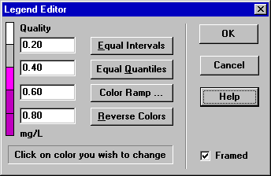

## **Overview Map:**

The Overview Map allows you to see where in terms of the overall system the main network map is currently focused. This zoom area is depicted by the rectangular boundary displayed on the Overview Map ([Fig. 7.5](https://epanet22.readthedocs.io/en/latest/7_map.html#fig-overview-map)). As you drag this rectangle to another position the view within the main map will follow suit. The Overview Map can be toggled on and off by selecting **View >> Overview Map**. Clicking the mouse on its title bar will update its map image to match that of the main network map

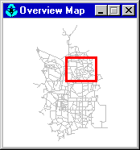

## **Map Display Options:**

* Select **View >> Options**
* Click the Options button image110 on the Standard Toolbar when the Map window has the focus
* Right-click on any empty portion of the map and select **Options** from the popup menu that appears

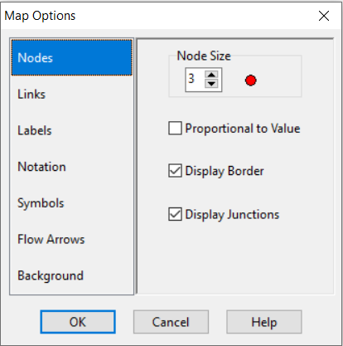

The dialog contains a separate page, selected from the panel on the left side of the form, for each of the following display option categories:

* *Nodes* (controls size of nodes and making size be proportional to value)
* *Links* (controls thickness of links, making thickness proportional to value)
* Labels (turns display of map labels on/off)
* *Notation* (displays or hides node/link ID labels and parameter values)
* *Symbols* (turns display of tank, pump, valve symbols on/off)
* *Flow Arrows* (selects visibility and style of flow direction arrows)
* *Background* (changes colour of map’s background)

**Node Options:**

The Nodes page of the Map Options dialog controls how nodes are displayed on the Network Map.

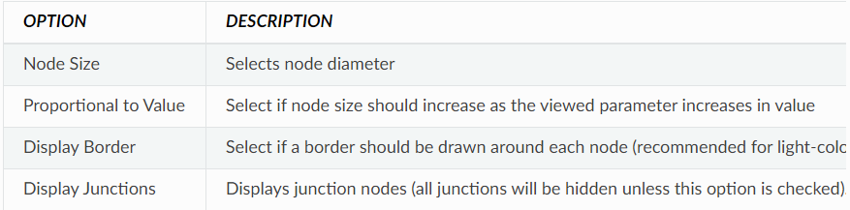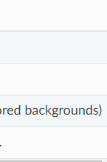

**Link Options:**

The Links page of the Map Options dialog controls how links are displayed on the map

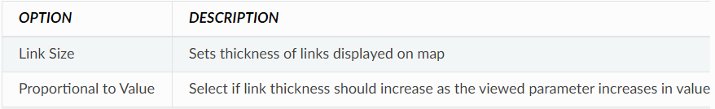

**Label Options:**

The Label page of the Map Options dialog controls how labels are displayed on the map.

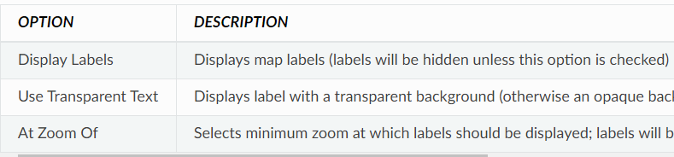

**Notation Options:**

The Notation page of the Map Options dialog form determines what kind of annotation is provided alongside of the nodes and links of the map.

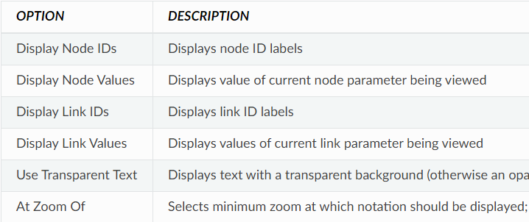

**Symbol Options**

The Symbols page of the Map Options dialog determines which types of objects are represented with special symbols on the map.

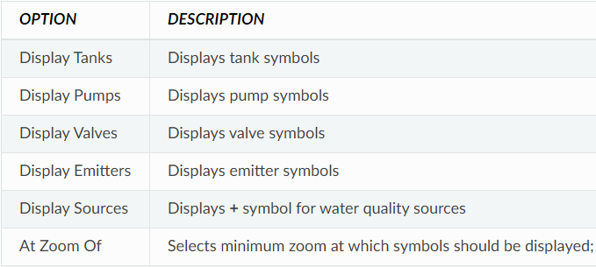

**Flow Arrow Options:**

The Flow Arrows page of the Map Options dialog controls how flow-direction arrows are displayed on the network map.

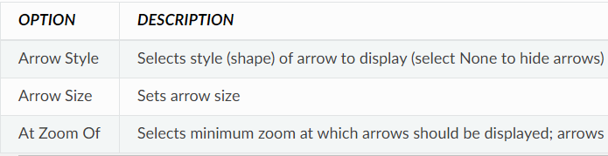

Flow direction arrows will only be displayed after a network has been successfully analysed.

**Background Options:**

The Background page of the Map Options dialog offers a selection of colours used to paint the map’s background with.